* Goal: Predicting which country a song is popular in using only the musical properties.
  + No contextual information such as artist, label, or year.
  + Using sequential musical relation between the segments of a song.
  + Can we differentiate the musical tastes of Countries?
* Dataset: Collected with Spotify API
  + Collected the most popular playlists in Spotify for 12 countries in a month in the last 19 years.
  + Songs appearing in playlists of multiple countries are discarded.
  + 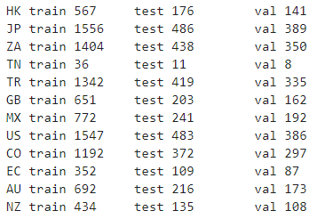
  + Songs are preprocessed by Spotify and divided into segments that are musically different than each other. Each segment is represented with two musical properties, pitch and timbre.
  + Timbre: Represented by a vector of 12. “Timbre is the quality of a musical note or sound that distinguishes different types of musical instruments, or voices. …The first dimension represents the average loudness of the segment; second emphasizes brightness; third is more closely correlated to the flatness of a sound; fourth to sounds with a stronger attack; etc.” <https://developer.spotify.com/documentation/web-api/reference/tracks/get-audio-analysis/>
  + Pitch: Represented by a vector of 12. It represents the dominance of 12 pitches in Chromatic Scale (<https://en.wikipedia.org/wiki/Chromatic_scale#Notes>) in the segment.
  + 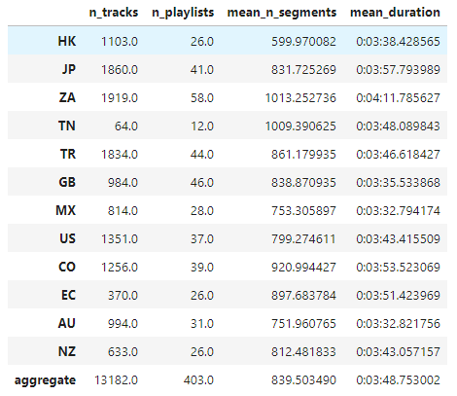
* Approach: Exploit the sequential structure of segments and use LSTM.
  + Architecture
  + Sampling
  + Training
  + Evaluation
* Preliminary Results
* Limitations
  + Some playlists are generated by Spotify and it is likely that they use the same features to curate the lists.

**For our knowledge**

**Pipeline:** Collect data 🡪 Country Specific Pickle 🡪 Sample during training